How to access the Studio App from the ZO landing page
WEB VERSION

- Click in the top right corner where the green circle icon is.
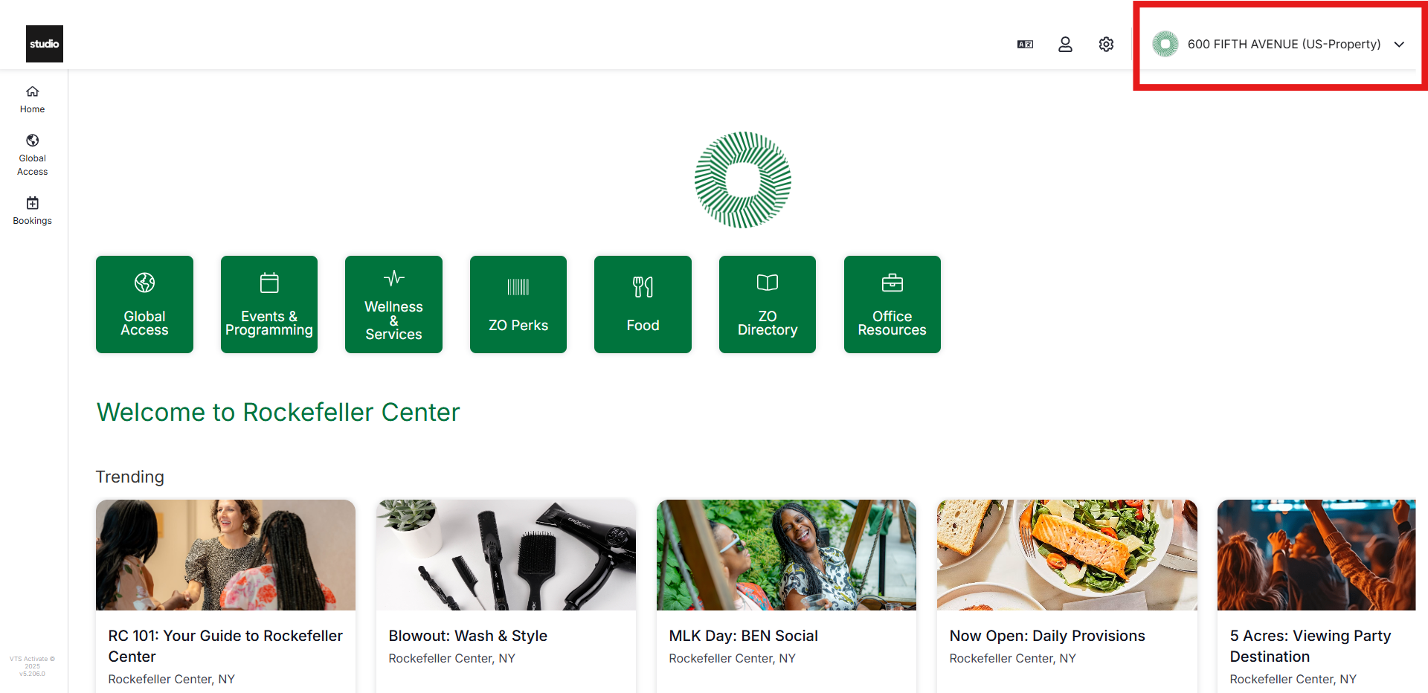

- Click the Studio App Icon that says “Studio – Global Studio at 1230 AoA”
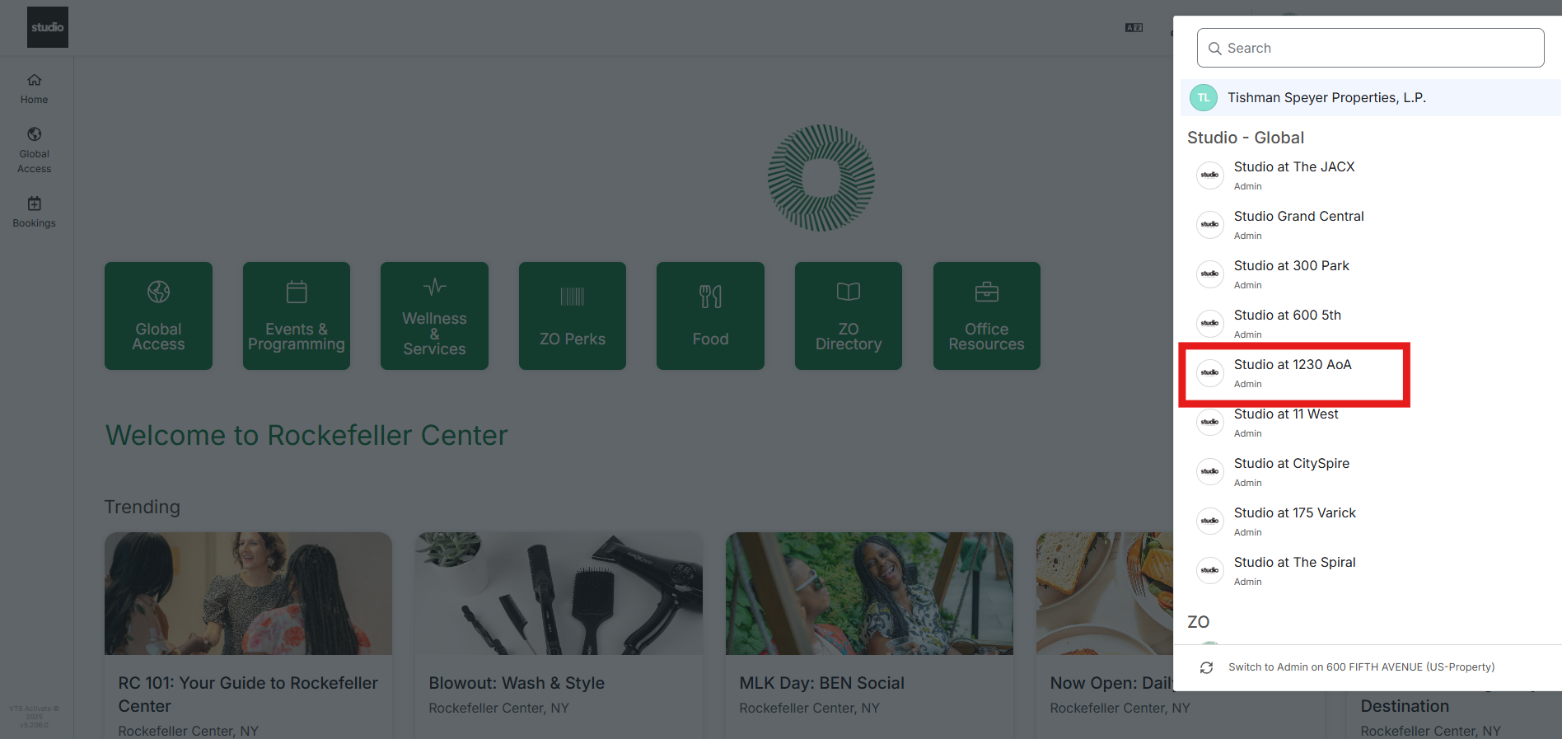

- Find your Guest Registration or Room Booking tiles as well as our weekly events!
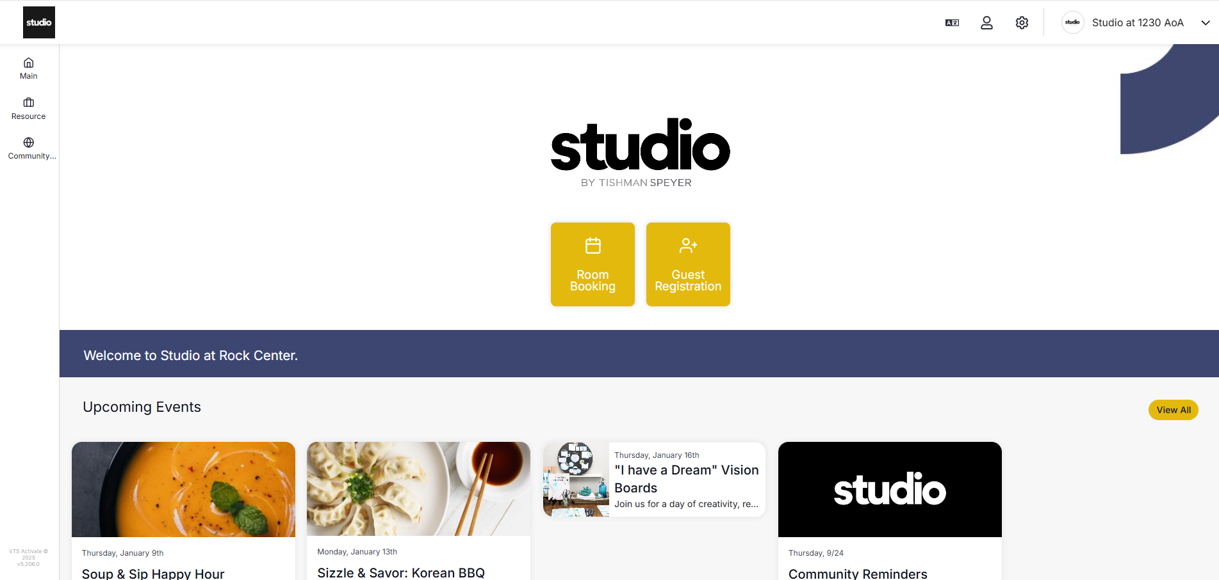
MOBILE VERSION
- From the ZO Amenities landing page - click the Account Icon on the bottom right corner.
- Select “Switch Workplace”
- Select “Studio - Global – Studio at 1230 AoA”
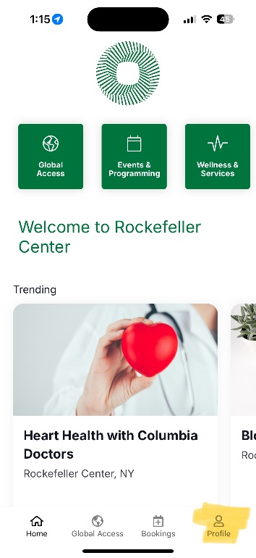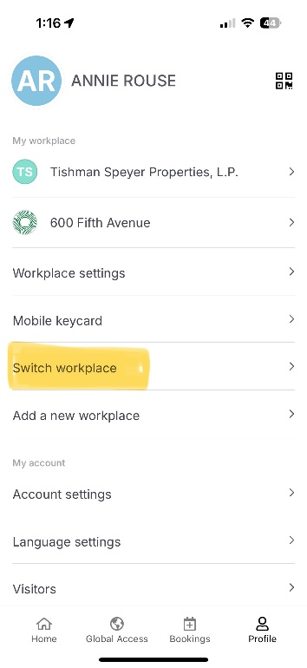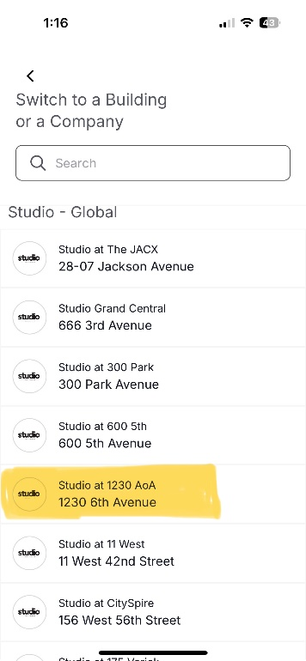
- Continue browsing our weekly member events, register guests, and book meeting rooms!
